C++ while and do...while Loop

In computer programming, loop repeats a certain block of code until some end condition is met.

There are 3 type of loops in C++ Programming:

* for Loop
* while Loop
* do...while Loop

**C++ while Loop**

The syntax of a while loop is:

while (testExpression)

{

// codes

}

where, testExpression is checked on each entry of the while loop.

**How while loop works?**

* The while loop evaluates the test expression.
* If the test expression is true, codes inside the body of while loop is evaluated.
* Then, the test expression is evaluated again. This process goes on until the test expression is false.
* When the test expression is false, while loop is terminated.

**Flowchart of while Loop**

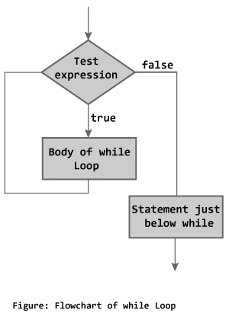

**Example 1: C++ while Loop**

// C++ Program to compute factorial of a number

// Factorial of n = 1*2*3...*n

#include <iostream>

using namespace std;

int main()

{

int number, i = 1, factorial = 1;

cout << "Enter a positive integer: ";

cin >> number;

while ( i <= number) {

factorial *= i; //factorial = factorial * i;

++i;

}

cout<<"Factorial of "<< number <<" = "<< factorial;

return 0;

}

**Output**

Enter a positive integer: 4

Factorial of 4 = 24

In this program, user is asked to enter a positive integer which is stored in variable number. Let's suppose, user entered 4.

Then, the while loop starts executing the code. Here's how while loop works:

1. Initially, i = 1, test expression i <= number is true and factorial becomes 1.
2. Variable i is updated to 2, test expression is true, factorial becomes 2.
3. Variable i is updated to 3, test expression is true, factorial becomes 6.
4. Variable i is updated to 4, test expression is true, factorial becomes 24.
5. Variable i is updated to 5, test expression is false and while loop is terminated.

**C++ do...while Loop**

The do...while loop is a variant of the while loop with one important difference. The body of do...while loop is executed once before the test expression is checked.

The syntax of do..while loop is:

do {

// codes;

}

while (testExpression);

**How do...while loop works?**

* The codes inside the body of loop is executed at least once. Then, only the test expression is checked.
* If the test expression is true, the body of loop is executed. This process continues until the test expression becomes false.
* When the test expression is false, do...while loop is terminated.

**Flowchart of do...while Loop**

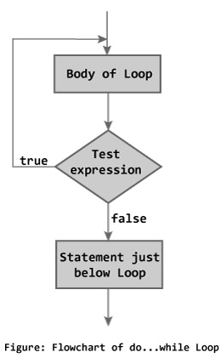

**Example 2: C++ do...while Loop**

// C++ program to add numbers until user enters 0

#include <iostream>

using namespace std;

int main()

{

float number, sum = 0.0;

do {

cout<<"Enter a number: ";

cin>>number;

sum += number;

}

while(number != 0.0);

cout<<"Total sum = "<<sum;

return 0;

}

**Output**

Enter a number: 2

Enter a number: 3

Enter a number: 4

Enter a number: -4

Enter a number: 2

Enter a number: 4.4

Enter a number: 2

Enter a number: 0